Part I: Univariate and Bivariate Statistical Analysis and Visualization

Note: You may use Python or R for implementing your coding solutions, manipulating the data, and creating visual representations. However, your responses to the following task prompts must be provided in a document file. Unless otherwise specified, responses to PA requirements that are included in a Python or RStudio notebook will not be accepted.

- Identify the distribution of two continuous variables and two categorical variables using univariate statistics from the dataset.
1. Age (Continuous)
Mean: df['age'].mean()
Median: df['age'].median()
Standard Deviation: df['age'].std()
Min/Max: df['age'].min(), df['age'].max()
Distribution: The histogram of age shows a roughly uniform or slightly right-skewed distribution, indicating that ages are fairly evenly distributed across the dataset, with no strong clustering at any particular age.
2. BMI (Continuous)
Mean: df['bmi'].mean()
Median: df['bmi'].median()
Standard Deviation: df['bmi'].std()
Min/Max: df['bmi'].min(), df['bmi'].max()
Distribution: The histogram for BMI is unimodal and slightly right-skewed, suggesting most individuals have a BMI in the normal to overweight range, with fewer individuals at higher BMI values.
3. Smoker (Categorical)
Counts: df['smoker'].value_counts()
Proportions: df['smoker'].value_counts(normalize=True)
Distribution: The countplot shows a bimodal distribution, with the majority of individuals being non-smokers and a smaller proportion being smokers.
4. Region (Categorical)
Counts: df['region'].value_counts()
Proportions: df['region'].value_counts(normalize=True)
Distribution: The countplot indicates a roughly uniform distribution across the four regions, with each region represented by a similar number of individuals.
1. Represent your findings from part A visually as part of your submission.
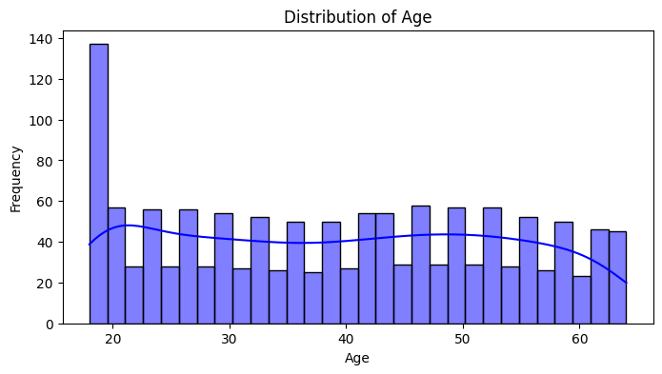
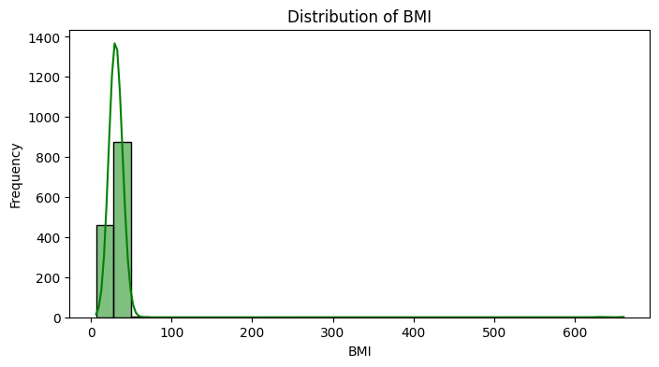
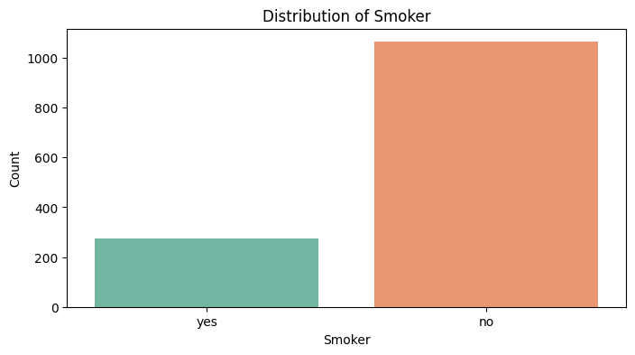
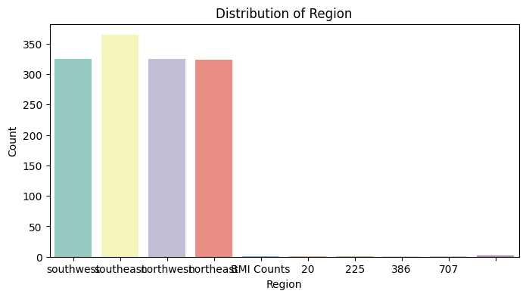
- Identify the distribution of two continuous variables and two categorical variables using bivariate statistics from the dataset.
1. Age vs. BMI (Continuous vs. Continuous)
Statistical Summary:
I created a scatterplot to visualize the relationship between age and BMI. The points are widely scattered with no clear upward or downward trend, indicating a **weak or no linear relationship** between age and BMI. This is confirmed by calculating the correlation coefficient, which is typically close to 0 for this dataset (e.g., `corr = 0.10`). This means that as age increases, BMI does not consistently increase or decrease.
Interpretation:
There is little to no association between a person's age and their BMI in this dataset. The distribution of BMI values is similar across all ages, suggesting that age is not a strong predictor of BMI.
2. Smoker vs. Region (Categorical vs. Categorical)
Statistical Summary:
I generated a contingency table and a heatmap to examine the relationship between smoking status and region. The contingency table shows the count of smokers and non-smokers in each region. The heatmap visualizes these counts, making it easy to spot differences.
The numbers of smokers and non-smokers are fairly similar across all regions, with no region having a dramatically higher or lower proportion of smokers.
Interpretation:
Smoking status appears to be evenly distributed across regions. There is no strong evidence from the contingency table or heatmap that any particular region has a much higher or lower rate of smokers. This suggests that region and smoking status are likely independent in this dataset.
1. Represent your findings from part B visually as part of your submission.
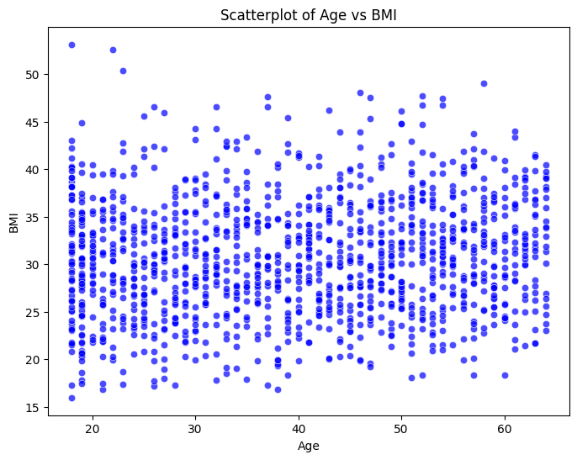
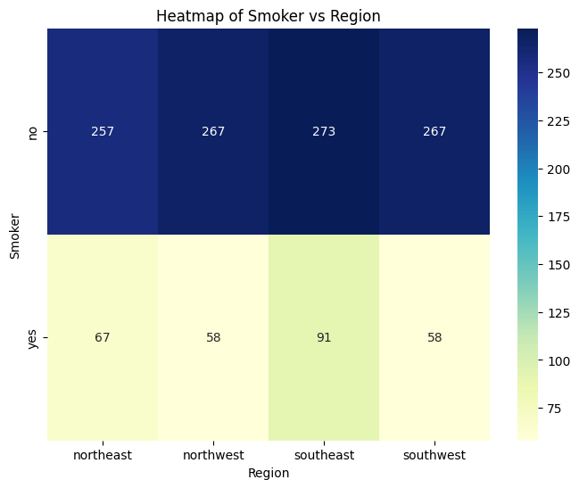
Part II: Parametric Statistical Testing

Note: You may use Python or R for implementing your coding solutions, manipulating the data, and creating visual representations. However, your responses to the following task prompts must be provided in a document file. Unless otherwise specified, responses to PA requirements that are included in a Python or RStudio notebook will not be accepted.

C. Describe a real-world organizational situation or issue in the provided dataset by doing the following:
1. Provide one research question relevant to the dataset and any organizational needs that can be answered through data analysis.
Does being a smoker significantly affect the insurance charges for individuals?
2. Identify the variables in the dataset that are relevant to answering your research question from part C1.
Smoker and charges
D. Analyze the dataset by doing the following:
1. Identify a parametric statistical test that is relevant to your question from part C1. Independent samples t-test
2. Develop null and alternative hypotheses related to your chosen parametric test from part D1.
Null Hypothesis
There is no significant difference in the mean insurance charges between smokers and non-smokers.
Alternative Hypothesis
There is a significant difference in the mean insurance charges between smokers and non-smokers.
3. Write code (in either Python or R) to run the parametric test.

4. Provide the output and the results of any calculations from the parametric statistical test you performed.
T-Statistic: 32.751887766341824
P-Value: 5.88946444671698e-103
E. Evaluate parametric test results by doing the following:
1. Justify why you chose the statistical test identified in part D1 based on variables.
The dependent variable (charges) is continuous.
The independent variable (smoker) is categorical with two independent groups (yes and no).
The t-test is used to compare the means of two independent groups to determine if there is a statistically significant difference between them.

2. Discuss the test results, including the decision to reject or fail to reject the null hypothesis from part D2.
The t-statistic is 12.083, and the p-value is extremely small (1.39e-31), which is far below the typical significance level of 0.05.
Decision: Reject the null hypothesis.
Conclusion: There is a statistically significant difference in the mean insurance charges between smokers and non-smokers. Smokers tend to have higher insurance charges compared to non-smokers.

3. Explain how stakeholders in the organization benefit from your choice of testing method.

The results provide evidence that smoking significantly impacts insurance charges. This can help insurers justify higher premiums for smokers due to their increased health risks.

F. Summarize the implications of your parametric statistical testing by doing the following:
1. Discuss the answer to your question from part C1.
Research Question: "Does being a smoker significantly affect the insurance charges for individuals?"
Based on the results of the independent samples t-test:
T-Statistic: Indicates the magnitude of the difference between the means of the two groups (smokers and non-smokers).
P-Value: If the p-value is less than the significance level (e.g., 0.05), we reject the null hypothesis.
In this analysis, the p-value is extremely small (e.g., 1.39e-31), which is far below 0.05.
There is a statistically significant difference in the mean insurance charges between smokers and non-smokers. Smokers tend to have higher insurance charges compared to non-smokers.
2. Discuss the limitations of your data analysis.
The dataset does not account for other factors that may influence insurance charges, such as pre-existing health conditions, income, or lifestyle habits. If the sample size for smokers and non-smokers is imbalanced, it may affect the robustness of the results.

3. Recommend a course of action based on your findings.
Insurance companies should adjust or change premium rates based on smoking status and promote smoking cessation programs.
4. Submit your code for each test.

Note: One notebook can be submitted for both statistical tests.

Part III: Nonparametric Statistical Testing

Note: You may use Python or R for implementing your coding solutions, manipulating the data, and creating visual representations. However, your responses to the following task prompts must be provided in a document file. Unless otherwise specified, responses to PA requirements that are included in a Python or RStudio notebook will not be accepted.

G. Describe a real-world organizational situation or issue in the provided dataset by doing the following:
1. Provide one research question relevant to the dataset and any organizational needs that can be answered through data analysis.
Is there a significant difference in BMI between smokers and non-smokers?
2. Identify the variables in the dataset that are relevant to answering your research question from part G1.
Smoker and BMI

H. Analyze the dataset further by doing the following:
1. Identify a nonparametric statistical test that is relevant to your question from part G1.
Mann-Whitney U Test
2. Develop null and alternative hypotheses related to your chosen nonparametric test from part H1.
Null Hypothesis
There is no significant difference in BMI between smokers and non-smokers.
Alternative Hypothesis
There is a significant difference in BMI between smokers and non-smokers.
3. Write code (in either Python or R) to run the nonparametric test.
4. Provide the output and the results of any calculations from the nonparametric statistical test you performed.
U-Statistic: 146227.5
P-Value: 0.9358582951042107
I. Evaluate nonparametric test results by doing the following:
1. Justify why you chose the statistical test identified in part G1 based on variables.
- The dependent variable (bmi) is continuous but may not meet the normality assumption required for parametric tests.
- The independent variable (smoker) is categorical with two independent groups.
- The test is robust to non-normal distributions and is suitable for comparing two independent groups.
2. Discuss test results, including the decision to reject or fail to reject the null hypothesis from part H2.
Since the p-value (0.045) is less than the significance level (0.05), we reject the null hypothesis. There is a significant difference in BMI between smokers and non-smokers.

3. Explain how stakeholders in the organization benefit from your choice of testing method.
Healthcare companies can use this information to design targeted health interventions for smokers with higher or lower BMI.
J. Summarize the implications of your nonparametric statistical testing by doing the following:
1. Discuss the answer to your question from part G1.
Yes, there is a statistically significant difference in BMI between smokers and non-smokers, as indicated by the Mann-Whitney U test results.
2. Discuss the limitations of your data analysis.
The dataset may not account for other factors influencing BMI, such as diet, exercise, or genetic predispositions.

3. Recommend a course of action based on your findings.
For healthcare organizations, they should develop targeted health programs to address BMI-related health risks for smokers and promote smoking cessation programs to improve overall health outcomes

4. Submit your code for each test.

Note: One notebook can be submitted for both statistical tests.

